Project: Moffat Bay Lodge
Course: CSD 460
Andres Melendez
Jeffery Reid
Jordany Gonzalez
Edgar Arroyo
Matthew Trinh
Description: Test plans for the Reservation Lookup and Contact Us Pages
Date: April 26, 2025

TABLE OF CONTENTS
Lookup Reservation Functional Test 2
Functional Test 2
Security Test 4

Lookup Reservation Functional Test

Test 1 | Functional Test
 | Test Objective: Verify that the lookup form correctly retrieves reservation details when valid information is provided. | Developer: Edgar Arroyo  Date tested: 2025/04/26 | Peer tester: Jordany Gonzalez  Date tested: 2025/04/26
Step | Action | Expected results: | Developer pass/fail | Tester pass/fail
1 | Open up the lookup reservation page | Confirmation number and email fields should be visible | Pass | 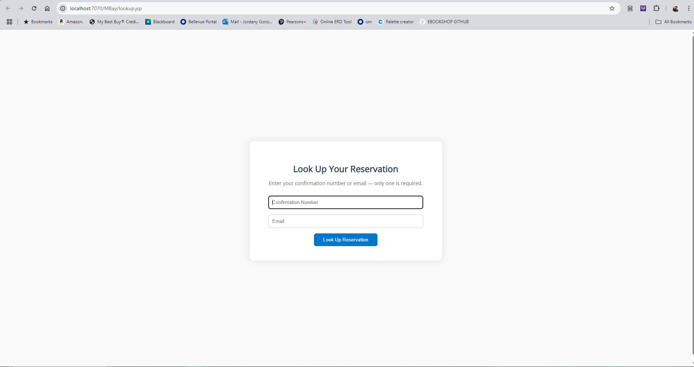  Pass
2 | Enter a valid confirmation number | The matching reservation should appear | Pass | 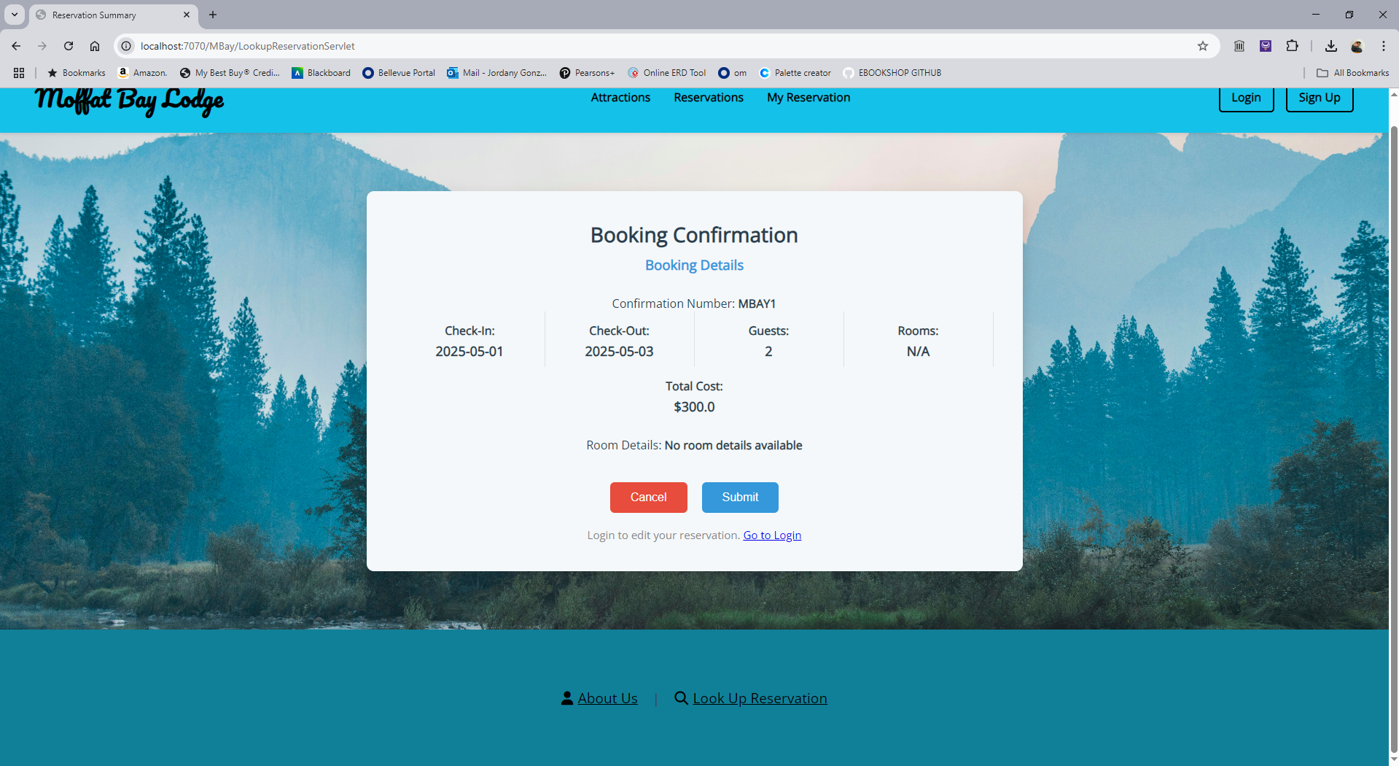  Pass
3 | Lookup with invalid confirmation number | Messages like reservation not found should appear | Pass | 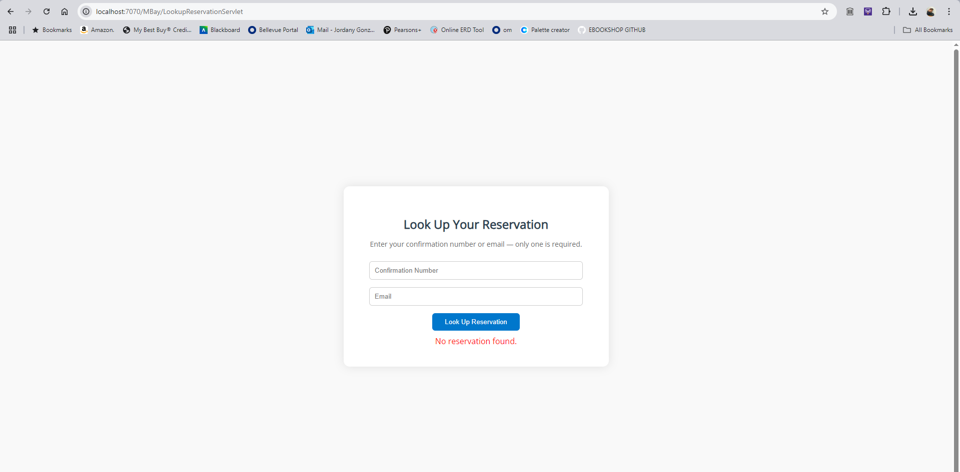  Pass
4 | Lookup with invalid email | Messages like reservation not found should appear | Pass | 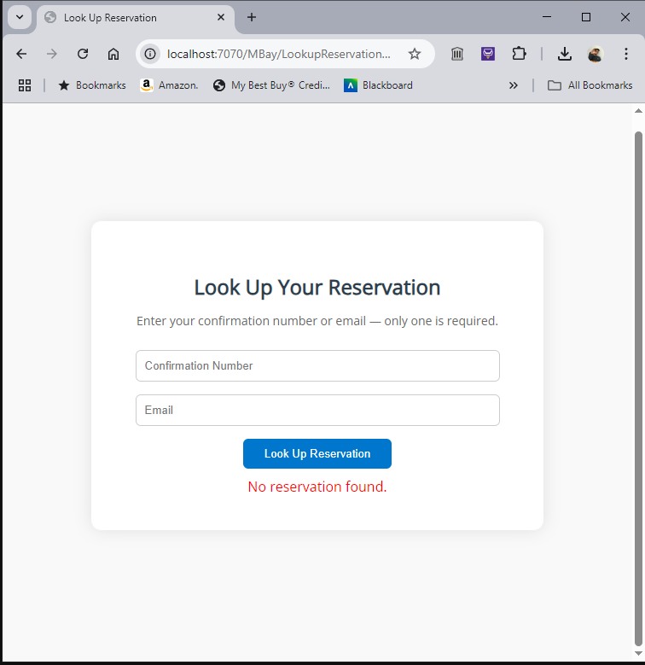  Pass
5 | Submit an empty form. | Some error message, like Please enter confirmation number/email should appear. | Pass | 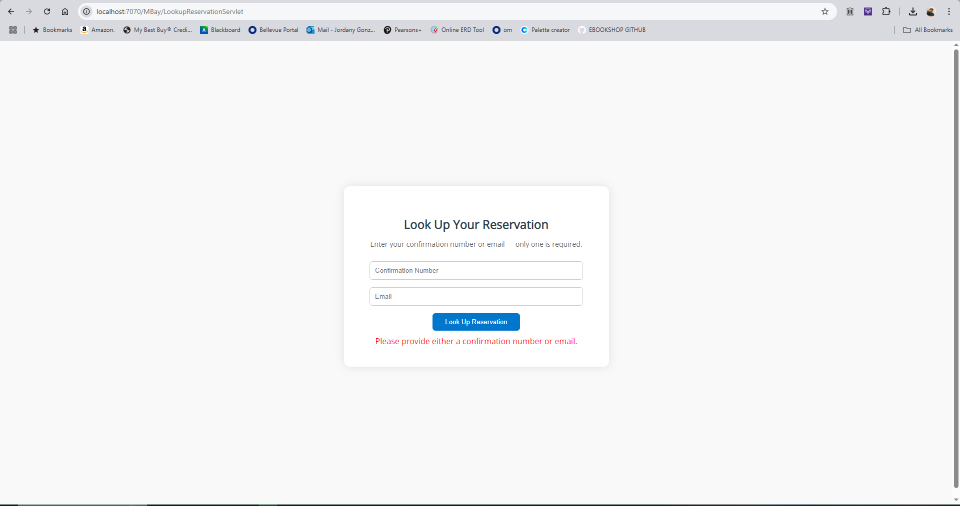  Pass
Comments | Comments should be substantive; this means there should be at least 2-3 well-structured sentences with constructive feedback.

Test 2 | Security Test
 | Test Objective: Ensure the lookup reservation page is protected against bad inputs | Developer: Edgar Arroyo  Date tested: 2025/04/26 | Peer tester: Jordany Gonzalez  Date tested: 2025/04/26
Step | Action | Expected results: | Developer pass/fail | Tester pass/fail
1 | Enter 100+ characters in the confirmation number and email fields | Form should reject the submission | Pass | 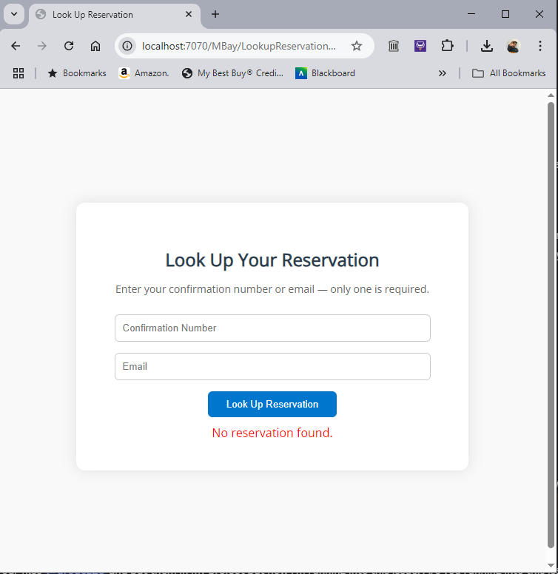  Pass
2 | Enter emojis or special characters and submit. | The form should be appropriately validated but rejected because of the use of nonstandard characters. | Pass | 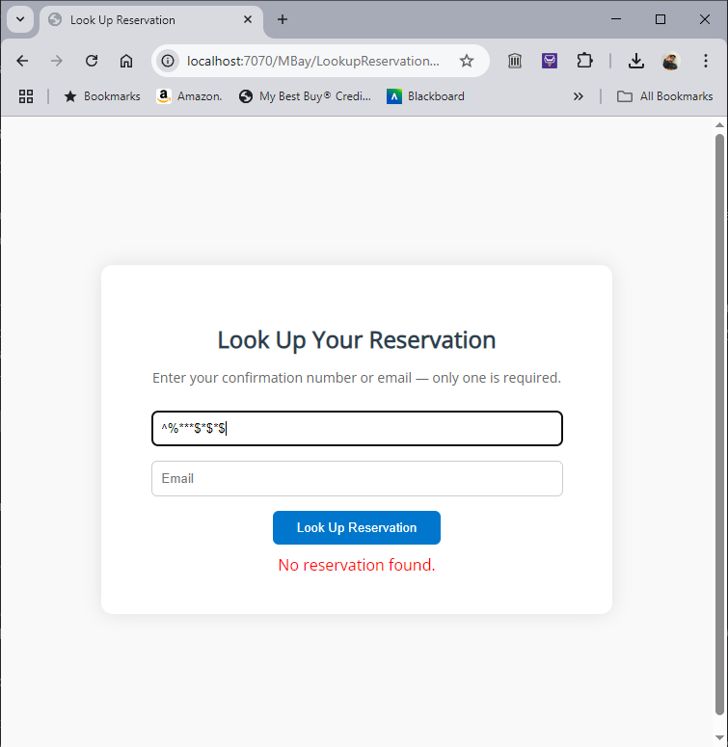  Pass
3 | Click the search button multiple times rapidly | The system should only process one request, no duplicate searches/errors | Pass | 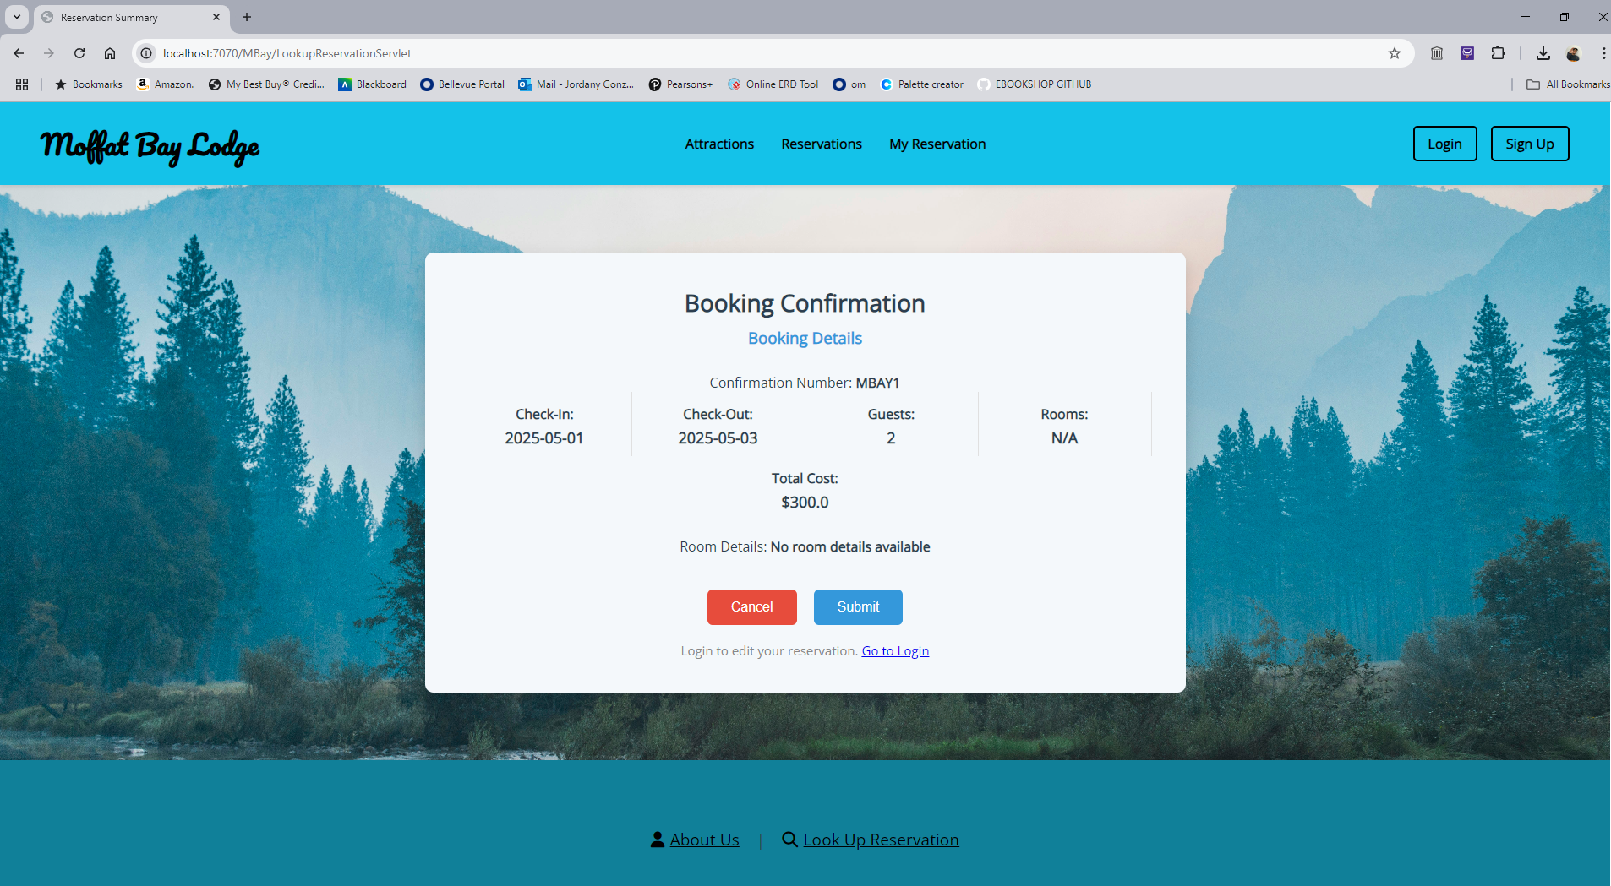  Pass
Comments | Comments should be substantive; this means there should be at least 2-3 well-structured sentences with constructive feedback.

